- Name of the teacher : Barnali Adhikary 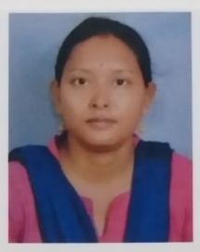
- Designation : SACT-II
- Qualifications : M.A
- Specialization :
- E-mail : barnalijpg44@gmail.com
- Teaching Experience (present college) : 9 Years
- College served : Mekliganj College
- Achievements : No
- Publications details (Books, Book chapters, Journals, Seminar/Conference Proceedings etc.) : No
- Awards/ Fellowship/Grants : No
- Teaching Experiences in other institutions : No
- Administrative responsibilities in College : No

