- Name of the teacher : SANKAR ROY
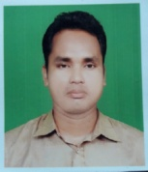
- Designation : SACT - I
- Qualifications : M.A, NET, SET
- Specialization :
- E-mail : sankarroy.mng00@gmail.com
- Teaching Experience (present college) : 5 years
- College served : Mekliganj ollege
- Achievements : NO
- Publications details (Books, Book chapters, Journals, Seminar/Conference Proceedings etc.) : NO
- Awards/ Fellowship/Grants : NO
- Teaching Experiences in other institutions : NO
- Administrative responsibilities in College : NO

